Binary Search Tree:

In order traversal:

if x ≠ NIL // Tree is non-empty
In-Order-Tree(x.left)
Print x.key
In-Order-Tree(x.right)

Tree Search:

Tree-Search(x, k): O(log(n)) //n is total number of nodes in tree
if x == NIL or k == x.key
return x
if k < x.key //search in left subtree
return Tree-Search (x.left, k)
else //search in right subtree
return Tree-Search (x.right, k)

Tree Minimum:

Tree-Minimum(x): O(log(n))
while x.left != NIL
x = x.left
//mininum is the most left child
return x
Tree Maximum:
Tree-Maximum(x): O(log(n))
while x.right != NIL
x = x.right
//maximum is the most right child
return x

Tree Successor:
Successor of node x: the node with the smallest key greater than x
Tree-Successor (x)
if x.right  NIL
//successor is on its right subtree
return Tree-Minimum(x.right)
y = x.p
//no right subtree,
successor is its oldest parent
while y  NIL and x == y. right
x = y
y = y.p
return y

Tree Insert:

Tree-Insert(T, z)
y = NIL and x = T.root
while x  NIL
y = x
//y points to currently visiting key
if z.key < x.key
x = x.left
else x = x.right
z.p = y
if y == NIL
T.root = z //tree is empty
elseif z.key < y.key //tree has one node
y.left = z
else y.right = z

Max-heap:

Binary Tree Structure:
Parent(i): i/2 if i is even; (i-1)/2, otherwise
Children(i): left child 2i and right child 2i+1

Max-heapify:

Max-Heapify (A, i)
l = left (i)
r = right (i)
if l ≤ A.heapsize and A[l] ≥ A[i]
largest = l
else largest = i
if r ≤ A.heapsize and A[r] ≥ A[largest]
largest = r
if largest ≠ i
exchange A[i] with A[largest]
Max-Heapify (A, largest)

Running Time: O(h)=O(log n)
(h: height of heap; n: number of nodes)

Heap Sort:

Heapsort(A)
Build-Heap(A)
For (i = length ... 2) do
Exchange A[1] with A[i]
A.heapsize = A.heapsize-1
Max-Heapify(A, 1)
Time Complexity: O(n logn)
Build-Heap: O(n logn)
MaxHeapify: (n-1) x O(logn)

Merge Sort:

Merge-Sort(A, p, r)
if p < r
q = floor[(p+r)/2] //divide into two small parts
Merge-Sort(A, p, q) //separately sort two small parts
Merge-Sort(A, q+1, r)
Merge(A, p, q, r) //combine two small parts

Merge Procedure:
i =1, j = 1
for k = 1 to m+n do
if X[i] < Y[j]
Z[k] = X[i], i = i+1
else
Z[k] = Y[j], j = j+1
Time Complexity: O(m+n)
Merge Sort time complexity:
T(n) = 2T(n/2) + n

Recursive Form: T(n) = 2T(n/2) + n
Induction Process (assume n=2k → k=log2n ):
T(n) = 2T(n/2) + n
= 2[ 2T(n/22) + n/2 ] + n = 22T(n/22) + 2n
= 22 [ 2T(n/23) + n/22] + 2n = 23T(n/23) + 3n
=…
= 2kT(n/2k) + k x n
= n T(1) + log2n x n
= n + log2n x n
Might need to find examples of these merge-sort procedures.

Quicksort:

Quicksort(A, p, r):
if p < r
Then q = Partition(A, p, r) //divide list A at q
Quicksort(A, p, q-1) //conquer left part
Quicksort(A, q+1, r) //conquer right part

Partition A from A[p] to A[r] with pivot A[r]
Result:
If p  k  i, A[k]  pivot A[r] // i indicates boundary of two parts
If i + 1  k  j – 1, A[k] > pivot A[r]
x = A[r]
i = p - 1
for j = p to r – 1 // j is used to scan list
if A[j]  x
i = i +1
exchange A[i] with A[j] //move smaller number forward
exchange A[i+1] with A[r] // put pivot A[r] in middle after partition
return (i+1)

Worst Case:
Partition into two parts: (n-1) and 1
No nothing is moved at each time
O(n2)

T(n) = T(n-1) + T(1) + n
= T(n-1) + T(1) + (n-1) + n
= …
= T(1) + 1 + 2 + ... + (n-1) + n
= [ n(n+1) ]/2
= O(n2)

Best case:
Partition in (almost) equal parts each time
O(n log n)

T(n) = 2T(n/2) + n
= 4T(n/4) + 2n
= 2kT(n/(2k)) + kn
= …
= (log2n)T(1) + (log2n)n
= O(n logn)

Bubble Sort:

Key Idea: compares each pair of adjacent items and swap them if they are in the wrong order.
Bubble Sort(A):
n = length(A)
repeat
swapped = false
for i = 1 to n-1
if A[i-1] > A[i]
swap A[i-1] and A[i]
// float down larger number
swapped = true
until not swapped //stop loop when swapped is false

Improved:
Bubble Sort(A):
n = length(A)
repeat
swapped = false
for i = 1 to n-1 //compare n-1 times per iteration
if A[i-1] > A[i]
swap A[i-1] and A[i]
swapped = true
until not swapped

Total Time Complexity:
Original Version: n x (n-1) → O(n2)
Improved Version: (n-1) + (n-2) + … + 2 + 1 = n(n-1)/2 → O(n2)

0-1 Knapsack and Greedy Algorithms:

Unit largest problem.

Huffman Codes:

No pseudocode available. Reference step by step example.

Depth first search:

Procedure of DFS
All vertices are White
For each vertex v do, if u is white then Visit(v)
Color v Gray
For each u adjacent to v do if u is White then Visit(u)
Color u Black //all neighbors have been visited

Runtime of DFS = O(V+E)
Visiting Vertices: operations of push and pop on stack; once per vertex O(V)
Exploring Edges: operations of scanning adjacency list; once per edge O(E)

Breadth first search:

Initialization
assigns  to all vertices: d(v)= 
color all white
Color s gray, d(s)=0, enqueue s in Q
For the head u of Q
dequeue Q to get u
for each v adjacent to u, //visit each neighbor first
color v gray
d[v]=d[u]+1 //compute the distance to the starting point
enqueue v in Q
color u black

Running-time = O(V+E)
Operations of enqueuing and dequeuing: once per vertex O(V)
Operations of scanning adjacency list: once per edge O(E)

Minimum spanning tree:

Prim’s MST algorithm:

V: set of vertices in graph G
VT: set of vertices in MST
Process:
Initially, let VT = Φ
Select an arbitrary vertex, e.g. s, to start a tree
While VT ≠ V
Select an edge e(u, v) such that u in VT, v in V-VT, and w(e) is minimum among all such edges
//choose an edge with connected vertex in a greedy manner
Endwhile

Kruskal’s MST:

E = {e1, e2, …, em}: set of edges in graph G
ET: set of edges in MST
VT: set of vertices in MST
Process:
Initially, let VT = {v1, v2, ..., vn} and ET = Φ
Sort edges in E such that e1 ≤ e2 ≤ e3 … ≤ em
For i = 1 to m // IEI
if ET U {ei} does not creat a cycle
//greedily choose an edge
ET = ET U {ei}
Endfor

Difference between Kruskal’s and Djikstra’s:

Prim’s: edge selection from connected component to new vertex set (vertices of new added edge are not in the same vertex set)
Kruskal’s: edge selection between two connected components (check cycle after each selection)

Shortest Path:

Graph G(V, E)
V = {v0, v1, v2, …, vn}: set of vertices
w(vi, vj): weight of edge e(vi, vj)
p(v0, v1, v2, …, vk): a path from v0 to vk
w(p) = w(v0, v1) + w(v1, v2) + … + w(vk-1, vk): weight of path p
Problems:
Single-Source Shortest-Paths: find a shortest path from a source s to every vertex v in V.
Single-Destination Shortest-Path: find a shortest path to a destination d from every vertex v in V.
Single-Pair Shortest-Path: find a shortest path from source s to destination d.

Bellman Ford:

BFS-based algorithm, shortest paths (tree) easy to reconstruct.
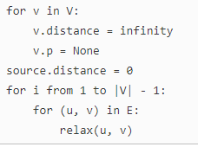
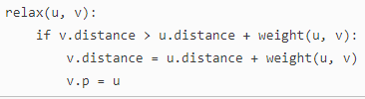

Djikstra’s shortest path:

Combines BFS and Prim’s algorithm
Better than BFS since non-negative weights
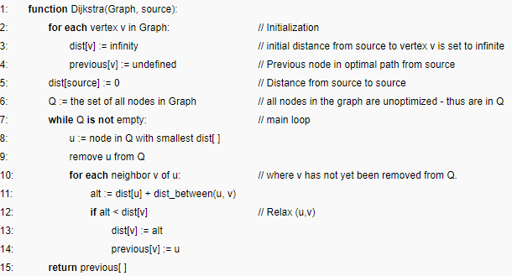
Bellman vs Djikstra:

Edge Weight:
Bellman-Ford can detect negative-weight cycle.
Dijkstra only deals with non-negative edge weights.
Key Idea:
Bellman-Ford is based on BFS.
Dijkstra resembles both BFS and Prim’s algorithm
Running Time:
Dijkstra is faster than Bellman-Ford

Karp’s 21 NPC Problem:
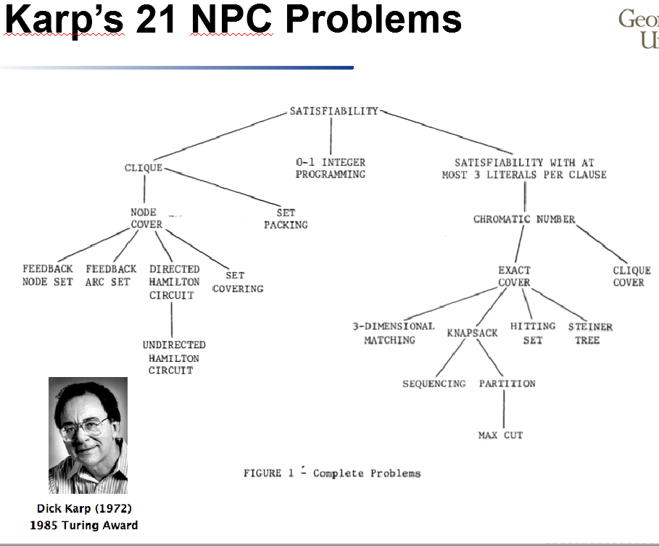

Vertex Cover:

Vertex Cover:
The set of vertices which has at least one endpoint in each edge
Minimum Vertex Cover (MVC):
The size of a vertex cover is minimum
Min Vertex Cover is NPC
If C is vertex cover, then V - C is an independent set

Process:
V’ = ⏀ //Initial vertex cover is empty
E’ = E //copy the edge set
while E’ is not empty
choose an edge e(u, v) from E’
V’ = V’ U {u, v} //add nodes u and v into cover set
remove from E’ every edge incident on either u or v
//delete all edges in E’ that are covered by either u or v to avoid repeated selection
return V’

Set Cover:

Given a set X of elements, a collection S1, S2, ..., Sm of subsets of X, the union of S1, S2, ..., Sm is equal to X, i.e, X = S1 U S2 U, …, U Sm
Set cover problem: find a set cover that has the minimum size

Given a set X of elements, a collection S1, S2, ..., Sm of subsets of X, the union of S1, S2, ..., Sm is equal to X, i.e, X = S1 U S2 U, …, U Sm
Set cover problem: find a set of subsets S to cover X such that this cover has the minimum size
Greedy set cover:

Key Idea: at each stage, choose a set S that covers the largest number of remaining uncovered elements.
Process:
A = X //initially, all elements are uncovered
C = ⏀ //initial set cover is empty
while U is not empty
select a subset S that maximizes |S ⋂ A|
// S ⋂ A is the set of uncovered elements that is included in S
A = A – S
C = C U {C}
return C

Traveling Salesman:

Graph coloring:

Given an undirected graph G, can the nodes be colored in k colors so that no adjacent nodes have the same color?

Graph Coloring: assign colors to certain elements of a graph subject to certain constraints.
Vertex Coloring
Most common graph coloring problem
Given k colors, find a way to color
the vertices of a graph such that
no two adjacent vertices have the
same color

Edge Coloring
Given k colors, find a way to color the edges of a graph such that no vertex is incident to two edges of the same color
Can be transformed into vertex coloring

Greedy coloring:

Given:
|V| vertices
Key idea:
Color first vertex with first color
Do the following for the remaining |V|-1 vertices
For current picked vertex, color it with the lowest numbered color that has not been used on any previously colored vertices adjacent to it.
If all previously colors have been used on its adjacent vertices, assign a new color to current vertex.

Welsh Powell:

Key Idea: color vertices in decreasing order of degrees.
Steps:
Compute the degree for each vertex
Sort vertices in decreasing order in terms of degrees
Color first vertex with first color
Do the following for the remaining |V|-1 vertices
For current picked vertex, color it with the lowest numbered color that has not been used on any previously colored vertices adjacent to it.
If all previously colors have been used on its adjacent vertices, assign a new color to current vertex.

